Help Your Students Sound like Natives
Paris Granville with Ed Wang and Ernesto Sanchez

Equip Students with the Language They Want
Often when the class discussion breaks down into English, it is because students are exited or astonished. Despite their best intentions, your lesson was so exciting that they cry out “YAAAAASSSSSSS!” Communication broke down under the sheer weight of student enthusiasm. Other times, students would like to disagree – politely. But, even the politest students may blurt out, “What the?” when confused. When released into the wild, their language will degrade even further; sometimes resulting in a complete breakdown.
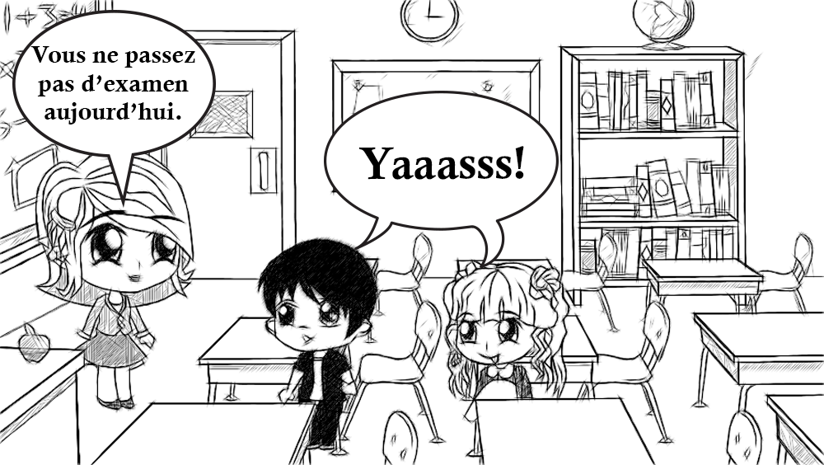
When Novice Learners are equipped with a few carefully-chosen interjections, they can begin to sound more natural. Each language and culture suggests authentic reactions that begin to reveal their perspectives. Each Native Speakers tend to favor certain expressions when reacting to new information due to the short reaction time. Sometimes the most appropriate expression is vague to language learners, yet crystal clear to native Speakers. But the ambiguity that make certain turns of phrase difficult for language learners also make them useful in a wide range of situations.

“It is what it is”
Since this tautology (Martin, 2013) is always true, language learners can use the expression “It is what it is” with imprecision. However, language learners who use this expression will immediately increase his perceived language ability despite their accent. This polyvalent expression (DeGirolami, 2009) allow the listener to interpret it in the most appropriate way.
- To shut down the topic of conversation – there is nothing more to be said
- To show that you are a realist – you are not going to get stuck on something you can’t change
- To always keep moving forward – there is no use pontificating on something that is immutable
When wielded with precision, ambiguity becomes subtly. The multiple meanings of this practice uncover an American perspective (Actfl, 2014) to always look toward the future with little regard for the past that grows from the expression, “What is done is done.” The American desire for constant progress has led to our greatest innovations and our greatest excesses.

Language to Be Themselves
Students use expressions in their first language to shore up their identity (Jaspal, 2009). They reveal their allegiances, beliefs and perspectives. When students begin to learn a world language they must fit their identity into a few memorized chunks of language. Their true personalities bubble underneath the “estoy bien.” Even in a second language, Americans tend to express themselves with words on the extremes of emotion. When translated directly into another language they can appear irrationally exuberant and unrelentingly optimistic to many cultures. A few strategic interjections and reaction words can help the students express their personality in a way a native speaker can grock (“Urban Dictionary: grock,” 2003).

Humans

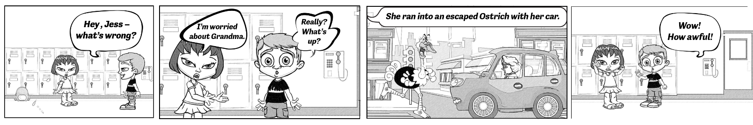

Versus Robots
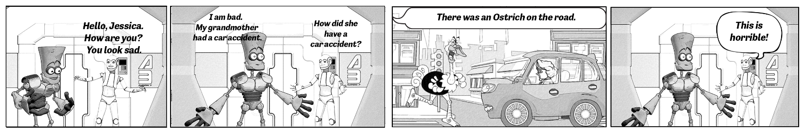

How to Choose
As students use these words daily to communicate their emotions, they will be an automated part of their speech patterns. By sprinkling these expressions appropriately in their conversation the students sound more natural and keep the attention of the native speaker.
As you think about the language that you teach, focus on the flavoring words that will help novice speakers get out of communication breakdown with grace. Students will need to rehearse the expressions many times in impromptu conversations, so they will only be able to learn about five of these expressions a year. In the first years choose expressions that have maximum flexibility to be sprinkled randomly in a conversation. Avoid slang as it will make students sound like refugees from a forgotten time in a few years or months.
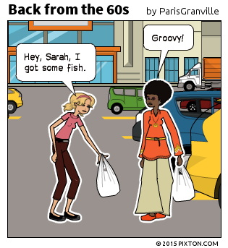
As students move into the intermediate level, they can begin to use expressions with more precision. These expressions tend to fall in logical categories.
- Enter a conversation
- Solicit someone’s opinion
- Summarize your ideas
- React positively or negatively
- Express agreement or disagreement clearly and politely
- Show that you are pondering an idea
- Say that you don’t know what to do
- React with confusion
- And more

Soupe spécial by Paris Granville
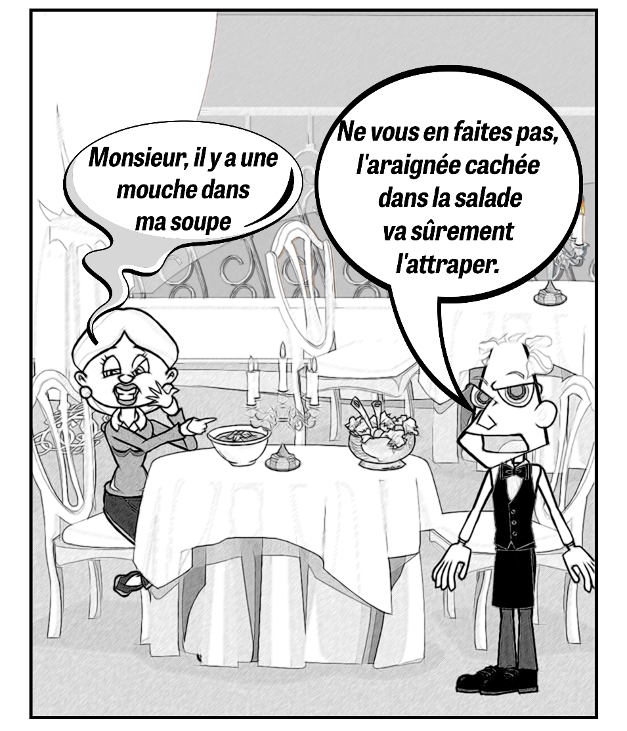

Ways to Teach
Since these expressions only gain meaning in the context of a conversation, they cannot be taught in a vocabulary list. They also often defy conventional grammar. The teacher can engineer a surprising situation by asking a student to come to class with pink hair, their favorite stuffed animal, or a surprise party for a student. The teacher will model a natural react to the situation in the target language. Then students are invited to create surprising phrases in the target language for the other to practice their natural reactions. The expression can be the word of the week, with a bonus offered to students who are able to work it into the conversation naturally. Finally, it can be added to the word wall.

Five Core Expression for Novice Learners
Chinese  (Lau, 2015) | Explanation | French  (Strasbourg, n.d.) | Explanation | Spanish  (Batzarov, n.d.) | Explanation
是吗？--shì ma? | Is that so? | Ah bon?!? | Really wow! (Surprise) or Really what? (Confusion) | Dime… | Tell me… (Open the dialog)
真的吗？-- zhēnde ma? | Really? | Sans doute | Partial agreement | De pronto… | Maybe…
那…… --nà… | (hold the vowel out as long as one wants, nààààà): well then… | C’est sûr ! | Total Agreement | Tal vez. | Perhaps… (Doubt)
对对对 -- duì duì duì | Right, right, right | C’est sans intérêt | Not worth doing or talking about | ¡No me digas! | (Surprise)
嗯 -- ng4 | yes (I heard what you just said) | C’est superbe ! | It’s great! | ¡Seguro! | For sure

A Call to Respond
WAFLT members will have many other ideas of expressions and ways to teach them. Teachers of Japanese, German, Vietnamese, Salish and other languages are invited to offer their thoughts to granvillep@bsd405.org . We also invite you to tweet @WAFLT #SoudlikeaNative. At the fall conference in Wenatchee, we can share ideas.
- What expressions will help your students sound more natural and keep the conversation in the target language?
- How would you teach them?
- What do these expressions say out the underlying cultural perspectives?

Bibliography
Actfl. (2014). World-Readiness Standards for Learning Languages World-Readiness Standards for Learning Languages, 2. Retrieved from http://www.actfl.org/publications/all/world-readiness-standards-learning-languages
Batzarov, Z. (n.d.). Spanish language: Interjections. Retrieved June 29, 2015, from http://www.orbilat.com/Languages/Spanish/Grammar/Spanish-Interjections.html
DeGirolami, M. (2009). PrawfsBlawg: “It is what it is”: Anatomy of an idiom. Retrieved June 29, 2015, from http://prawfsblawg.blogs.com/prawfsblawg/2009/05/as-ive-begun-to-go-to-conferences-and-learn-what-legal-academic-life-is-all-about-ive-come-also-to-appreciatesome-of-the-man.html
Jaspal, R. (2009). Language and social identity: a psychosocial approach | Rusi Jaspal - Academia.edu. Retrieved June 29, 2015, from http://www.academia.edu/200226/Language_and_social_identity_a_psychosocial_approach
Lau, J. (2015). Mandarin Chinese Parts of Speech: (叹) interjection. Retrieved June 29, 2015, from http://www.yellowbridge.com/chinese/partsearch.php?part=interj
Martin, L. J. (2013). It Is What It Is | Thought Catalog. Retrieved June 29, 2015, from http://thoughtcatalog.com/laura-jayne-martin/2013/06/it-is-what-it-is/
Strasbourg, U. de. (n.d.). Français langue étrangère. Retrieved June 29, 2015, from http://fle.u-strasbg.fr/webl/wflebao/chap03.htm
Urban Dictionary: grock. (2003). Retrieved June 29, 2015, from http://www.urbandictionary.com/define.php?term=grock

